EXP2-4 Part 2 Report M1
Group members: Zhang Yuchen, Wang Yuhan, Zheng Junhao, Che Xuanming, Wang Yixuan, Han Yujia
I. Introduction
To identify the factors influencing bearing strength, the experimental team conducted a factorial design experiment. The factors included Temperature, Accelerator, Sulphur, and Mould Time Type, with each factor being assigned two distinct levels. Statistical analysis was then performed to determine the factors affecting the strength of the final filled material.

II. Results
Table 1 presents the experimental results where factors A (Temperature), B (Accelerator), C (Sulphur), D (Mould Time) are labelled as specified, with AB denoting their interaction effect. The Y' and R effects represent impacts on product performance and reliability, respectively. Numerical values highlighted in yellow indicate cases where either the Y' or R effect exceeds 1.5×random variation, demonstrating statistically significant differences between factor levels rather than random errors. From the table, it can be observed that temperature and Accelerator influence product performance, with interactions present between temperature and Accelerator, temperature and vulcanizing agent, and Accelerator and vulcanizing agent.
Table 1. Effect of Y’ and R
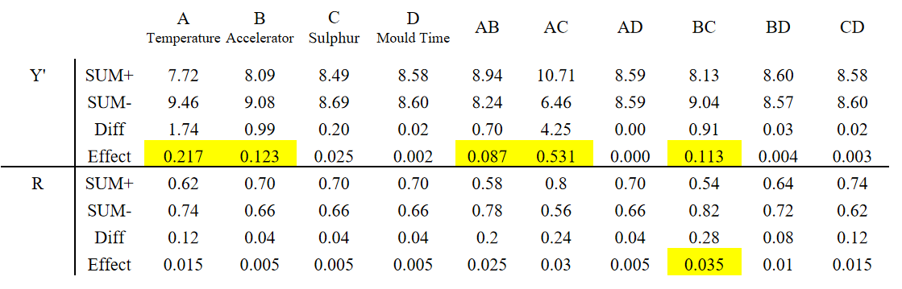
III. Analysis
From the table, it can be observed that the of A and B influence the product performance, where A has the greatest impact, followed by B. But the change of A or B doesn’t affect much the stability and the reliability of the product. This may be because higher temperatures accelerate the polymer crosslinking rate, leading to more complete crosslinking and improved performance. [1] The accelerator may promote the formation of active intermediates (e.g., polysulfidic salts), reducing the activation energy of the reaction. [2]

Regarding the interaction effects between factors: AB, AC, and BC all exhibit interactions, and the combined influence of B and C may be critical to the product’s reliability.

For AB: Elevated temperature increases the reaction rate, while the accelerator further reduces activation energy through catalytic action. However, excessive temperature may deactivate the accelerator, leading to a decline in reaction rate and product performance degradation.

For AC: Higher temperatures accelerate the opening of sulfur rings and crosslinking reactions. However, excessive heat may deactivate the vulcanizing agent or trigger side reactions with the rubber backbone (e.g., cyclization), reducing product performance.[2]

For BC: The accelerator may react with the vulcanizing agent rather than effectively catalyzing the rubber polymerization, causing side reactions during polymerization and impacting product performance. Furthermore, the reaction between the accelerator and vulcanizing agent could destabilize the primary polymerization process, leading to unstable or unreliable product performance.

For factors C and D and for the interactions AD, BD, and CD, it can be concluded that C and D have no significant impact on the performance of the rubber sheet, and there are no significant interactions between A and D, B and D or C and D. This may be because rubber synthesis typically involves addition polymerization, where molecular weight is independent of reaction time. [3] Prolonging the reaction time does not increase molecular weight, and thus, performance does not change significantly. Similarly, interactions between time and other factors are likely minimal.

IV. Conversation discussion
Table 2. Discuss the correctness of people's viewpoints in Blamestorming conversations based on experimental results
Person | Conversation | Result |  | Discussion
 |  | Single-factor | Two-factor
Jimmy's Hypothesis | “Those bearings were particularly large, maybe they weren’t achieving the moulding temperature all the way through” | Temperature will affect the final performance  （A √） | AB √ | While Jimmy and Bill's hypotheses are correct, they are not comprehensive.
Bindha's Consideration | “Wasn’t that about the time we changed the accelerator? Our old supplier closed down and we had to find a new one” | Accelerator will affect the final performance  (B √)
Bill's Estimation | “Maybe that wasn’t long enough for those big ones” | The dosage of the sulfurizing agent will not affect the final performance  (C ×) | AC √  BC √ | Although Bindha's consideration is not entirely accurate, it does hold some merit.
Mohammed's Concern | “The calculated amounts of the sulphur cross-linker are done in volume per cent but we measure out 2 parts per hundred rubber in the compounding mill, what if she got it the wrong way round?” | Processing time will not affect the final performance  (D ×) | AD ×  BD ×  CD × | Mohammed's concern is unfounded.

V. Design reflection
The following table delineates the comparative analysis between Part 1 experiments and factorial design experiments across methodological dimensions and resource allocation, disclosing a 50% divergence in practical outcomes. This substantial discrepancy indicates Part 1's limited capacity for accurate identification of latent factors and complete failure in reliability determination.

The former methodology requires substantially fewer experimental iterations than the latter. This operational disparity originates from their distinct theoretical foundations: Part 1 experiments implement combinatorial mathematics principles through permutation-based arrangements, while factorial designs adopt statistical hypothesis-testing frameworks. Both methodologies incorporate evaluations of individual factor effects and direct factor interactions. The combinatorial approach theoretically optimizes experimental economy via mathematical minimization protocols, purporting efficient factor effect isolation. However, its dependence on single-factor comparative analysis fundamentally compromises statistical rigor, introducing systematic bias risks in conclusion formulation. In contrast, factorial experiments employ variance decomposition mechanisms that enable precise effect magnitude estimation, thereby demonstrating superior engineering solution validity. Crucially, neither methodology possesses capability for effect polarity assessment (enhancing/deteriorating) or quantitative intensity determination.

Counterintuitively, Part 1 experiments consumed over 50% more human resources and temporal investment compared to factorial experiments. This resource paradox stems from Part 1's single-replication conclusive paradigm requiring near-zero error tolerance thresholds, necessitating exhaustive pre-experimental calibration cycles and protocol validation. Consequently, this stringent error-control framework paradoxically escalates operational workload while yielding diminished result accuracy. However, the purported two-day timeframe for factorial experiments appears impractical, as fabricating 16 specimens daily exceeds feasible production capacity in typical laboratory settings.

Table 3. Differences between two experiment
 | The experiment in part 1 | The factorial design experiment
Experimental design method | A partial factor design (5 samples) was adopted. | A full-factor design (2⁴ = 16 experiments) was adopted to test all factor combinations.
Sample size | -5 samples  -Two indicators were tested for each sample, and each indicator was repeated three times | - 5 samples  - The tensile modulus of each sample was tested 3 times
Total number of tests | 30 times | 48 times
Equipment requirements | Mold heating equipment, open mill, compression testing machine, universal testing machine + shearing fixture | Balance, open mill, die press, tensile testing machine
Required manpower | 2 technicians + 1 data analyst | 1 technician
Required time | 5 days (including equipment calibration) | 2 days (sample preparation + testing)

VI. Future plan
5.1 The handling of problem materials
For the materials identified as problematic in this instance, it is essential to promptly contact the customers, notify them of the specific issues with the materials, extend a formal apology, and proactively offer replacements with new materials to mitigate potential further losses.
5.2 A more in-depth analysis of these factors
The current experiments have only initially identified which factors have caused the product issues. However, to determine the mechanism of action of the influencing factors, further experiments are needed. Additionally, only four factors and their pairwise combinations were considered, lacking in-depth analysis of the correlations among more factors. It is suggested to set more quantitative levels for more identified individual factors to determine the best choice and consider the combinations of these factors to explore the essence of the existing problems in the process.
5.3 Future operations
Implement the "double-check by two people + first-piece sample retention" system to reduce the probability of product quality issues caused by human operation. In addition, conduct regular random inspections of sample quality to promptly identify defective products and minimize subsequent greater losses.

VII. Reference
[1] Lee KC, Yusoff NAM, Othman N, Mohamad Aini NA. Effect of vulcanisation temperature on curing characteristic, physical and mechanical properties of natural rubber/palygorskite composites. IOP Conference Series: Materials Science and Engineering. 2017 Jul;223:012017.
[2] Wang M, Zhu J, Zhang S, You G, Wu S. Influencing factors for vulcanization induction period of accelerator / natural rubber composites: Molecular simulation and experimental study. Polymer Testing. 2019 Dec 1;80:106145–5.
[3] The relationship between time and temperature of the vulcanization and accelerator [Internet]. Rubber-accelerator.com. 2025 [cited 2025 May 23]. Available from: http://www.rubber-accelerator.com/news/The-relationship-between-time-and-temperature-of-the-vulcanization-and-accelerator.html

